**ASSIGNMENT-1**

Name : Dhruv Sharma

Roll No: 21124012

Objective : To create a basic VR game with a virtual environment in Unity that includes a ground plane, a skybox, environmental objects, lighting, and simple VR interaction. The player should be able to grab and move the grabale objects in the environment to score points.

**TASK 1 : Setting unity project and configuring vr environment**

Steps :-

* Create a new unity project in URP{universal rendering pipeline} 3d project.
* Installing XR interaction toolkit
* Installing XR plugin management
* Setup the XR origin (VR)

Screenshots :-

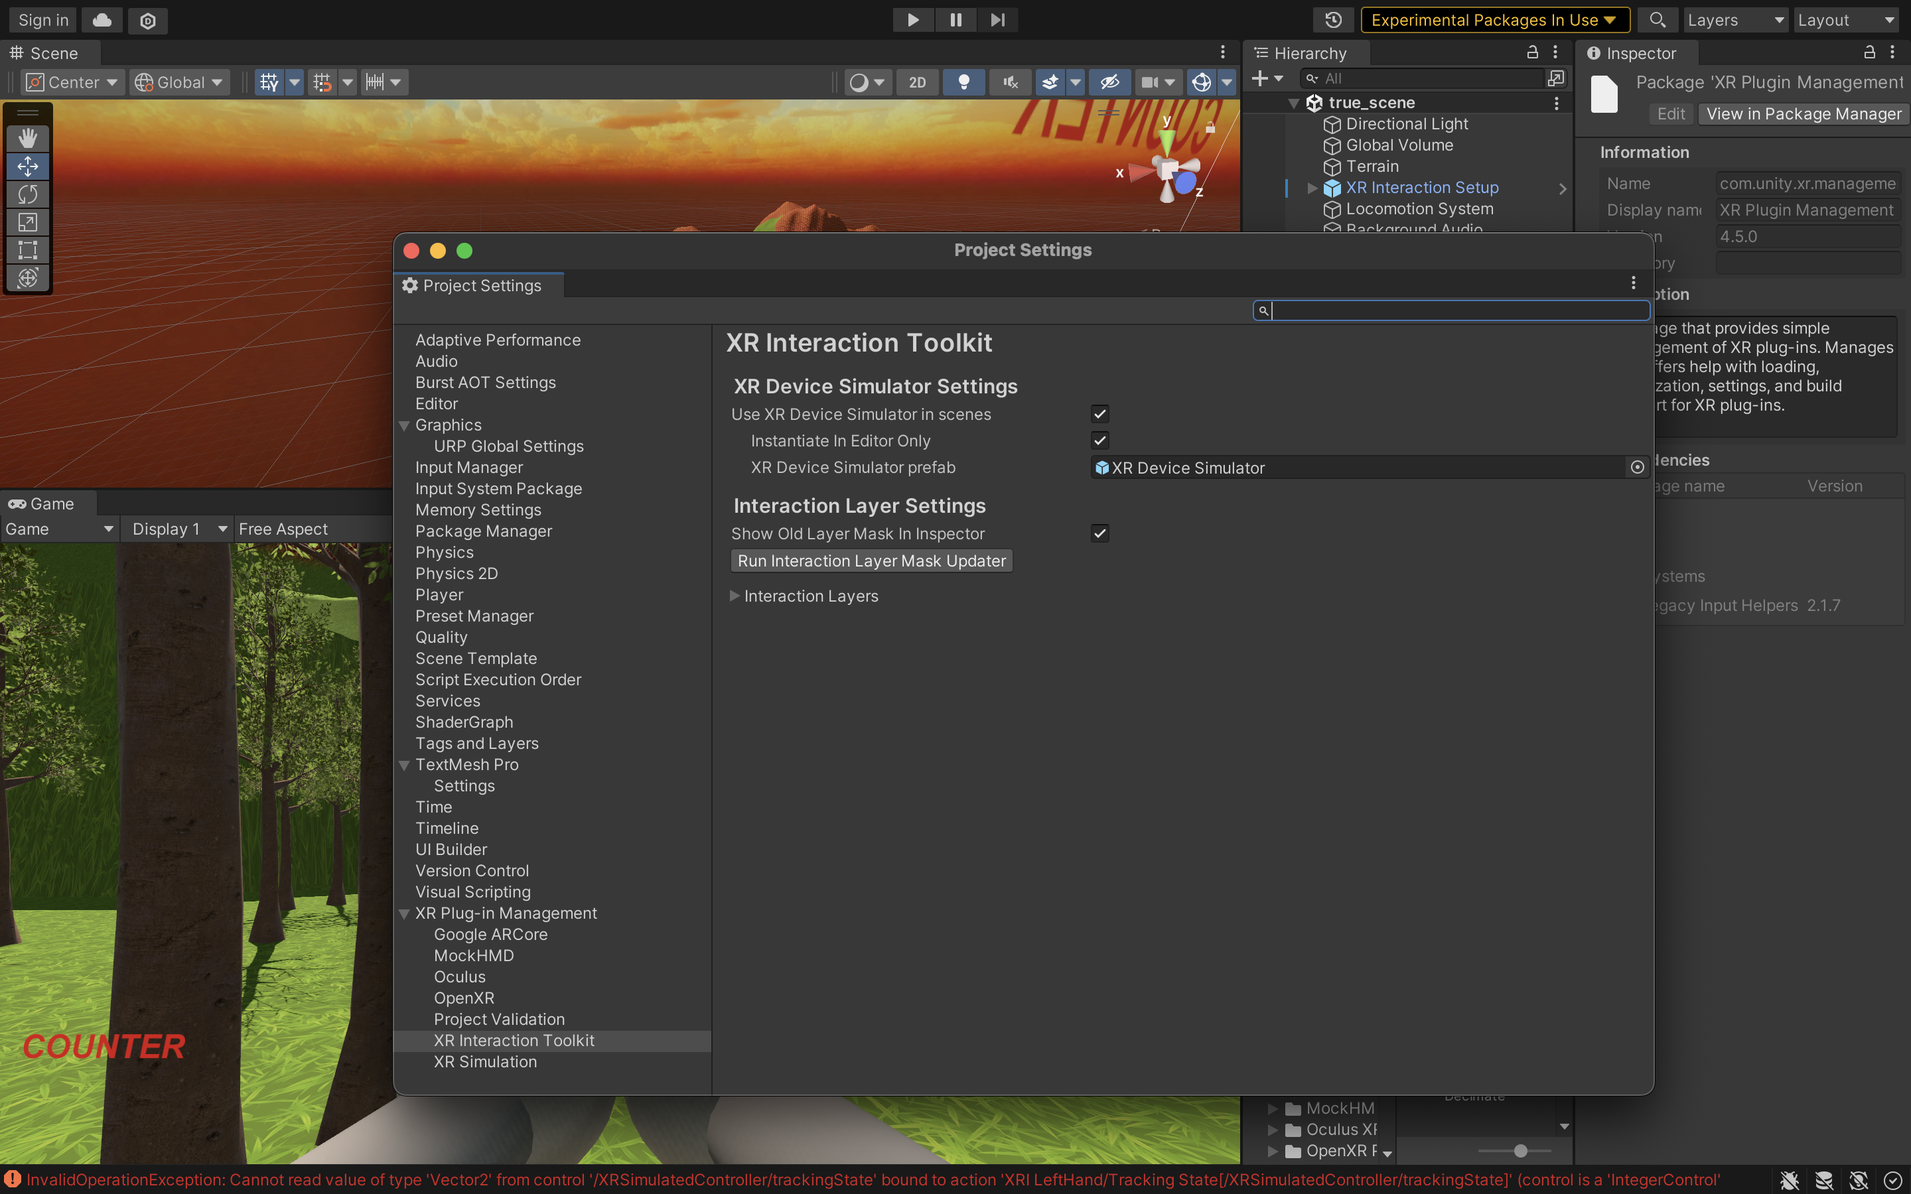

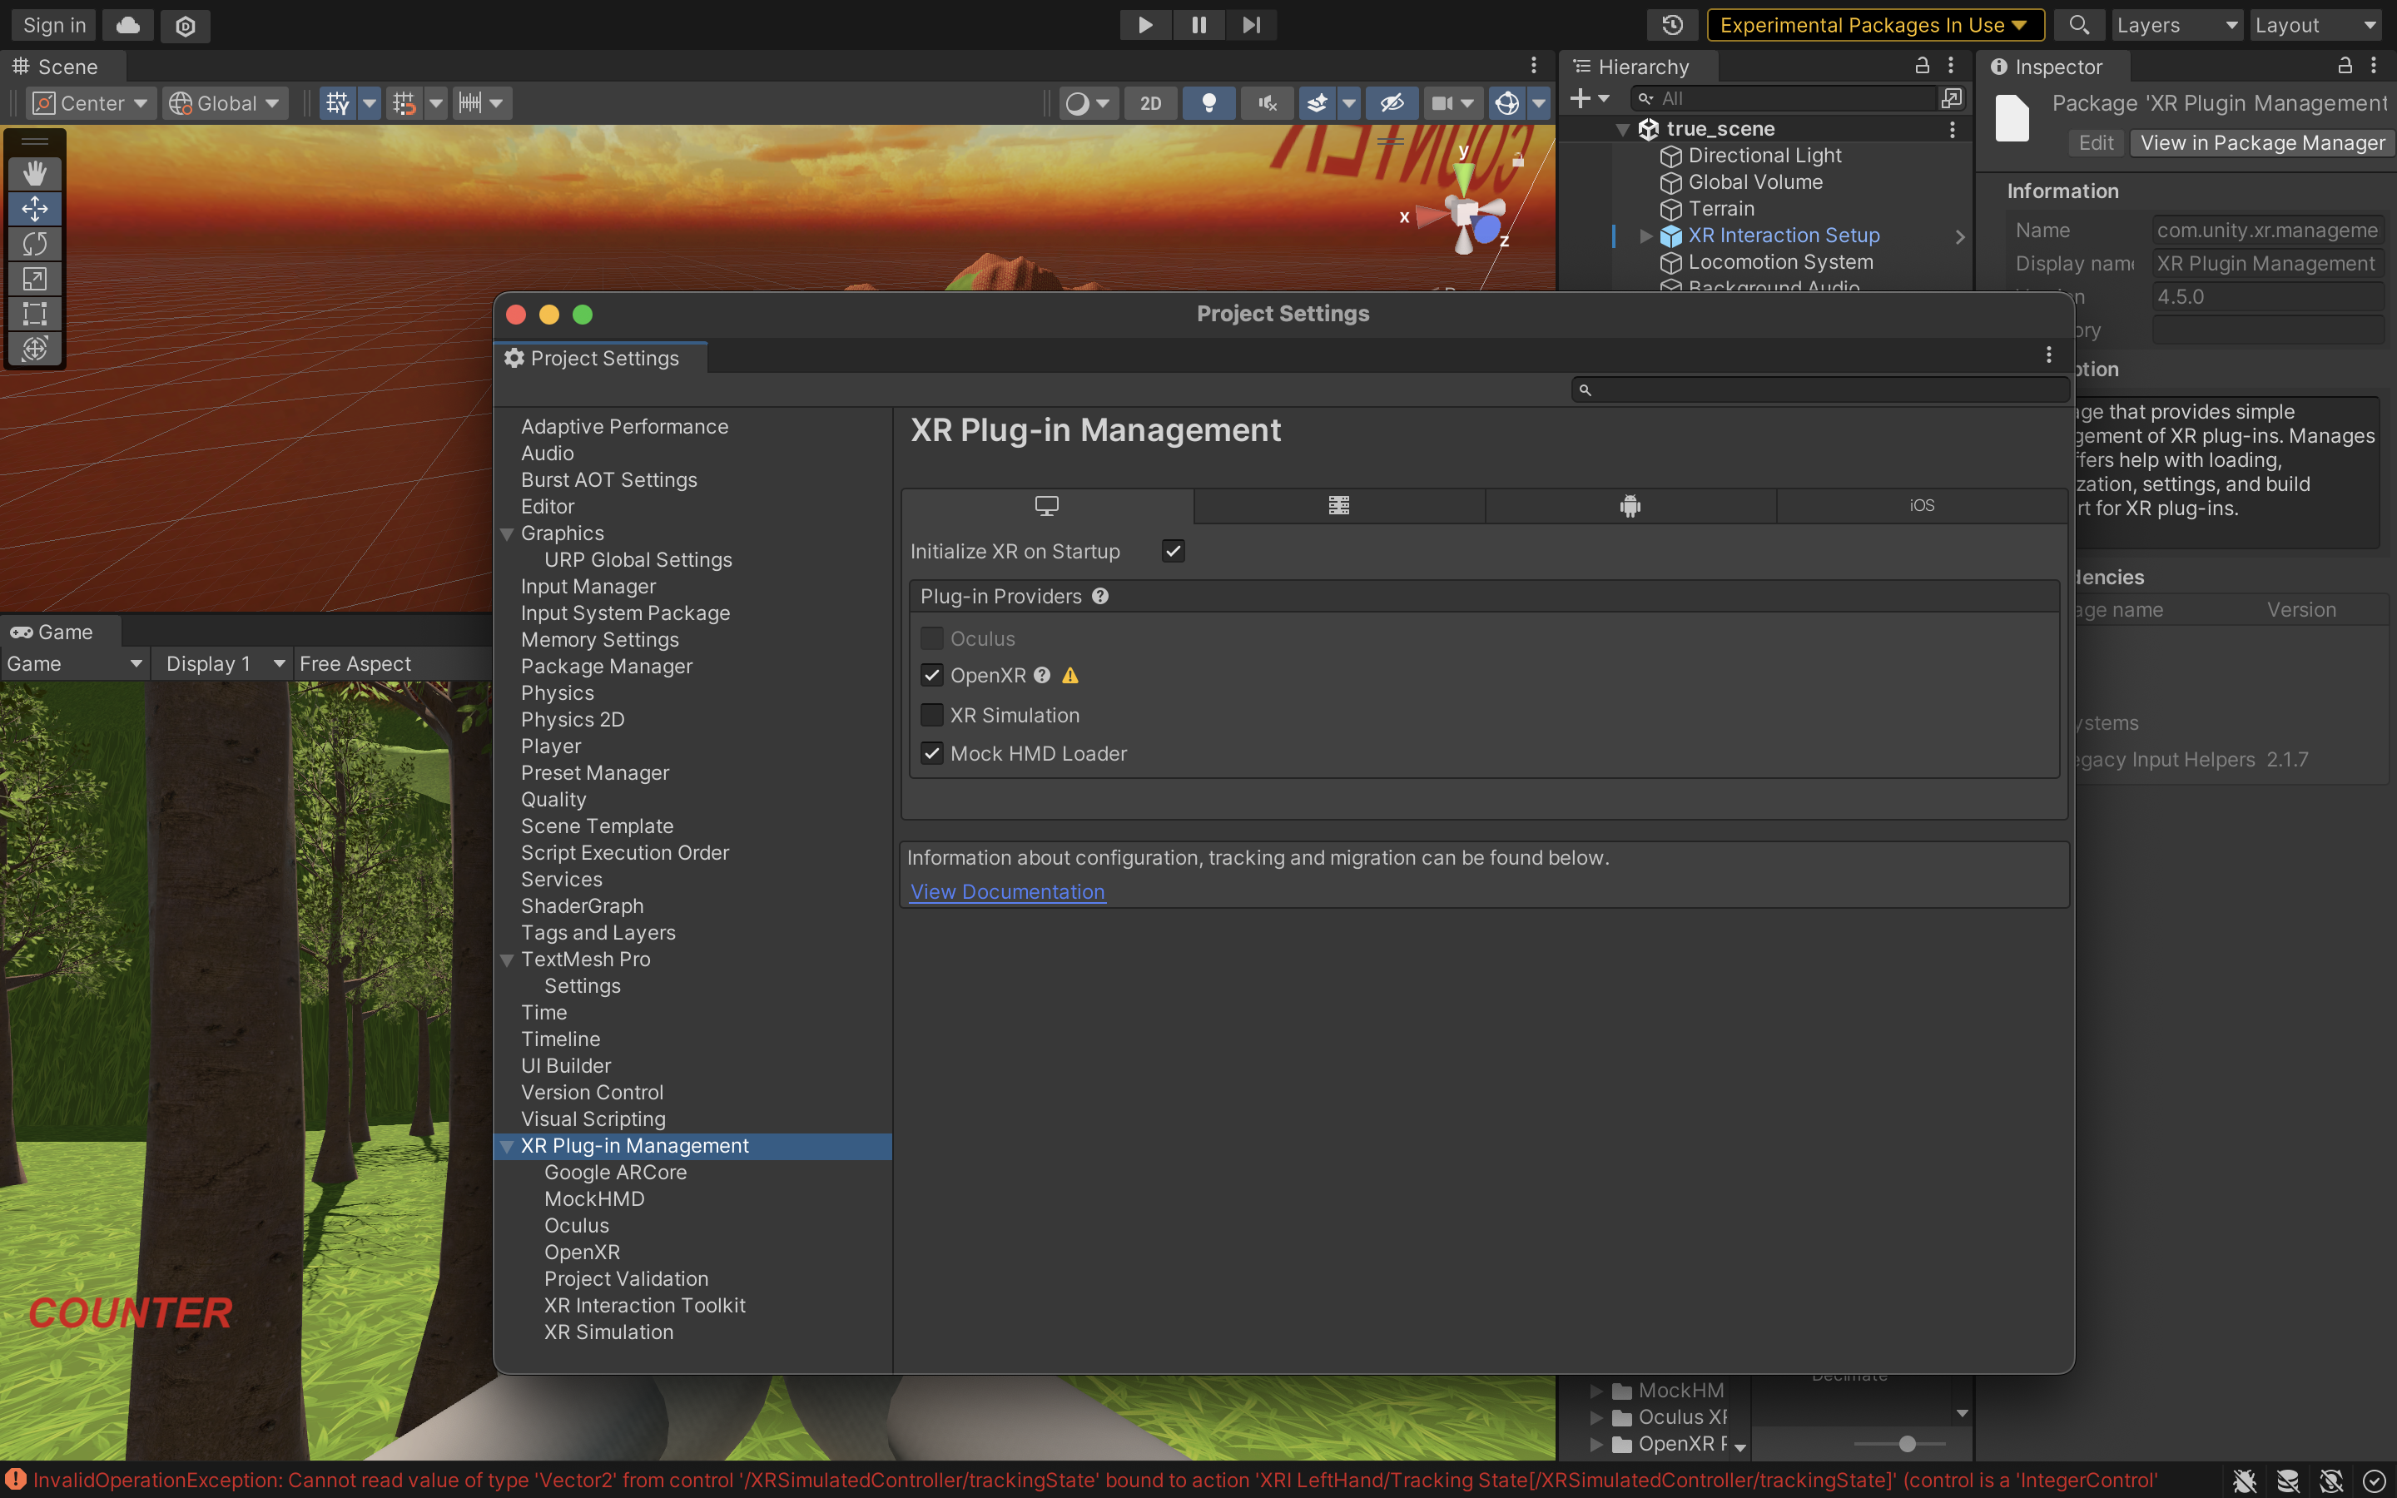

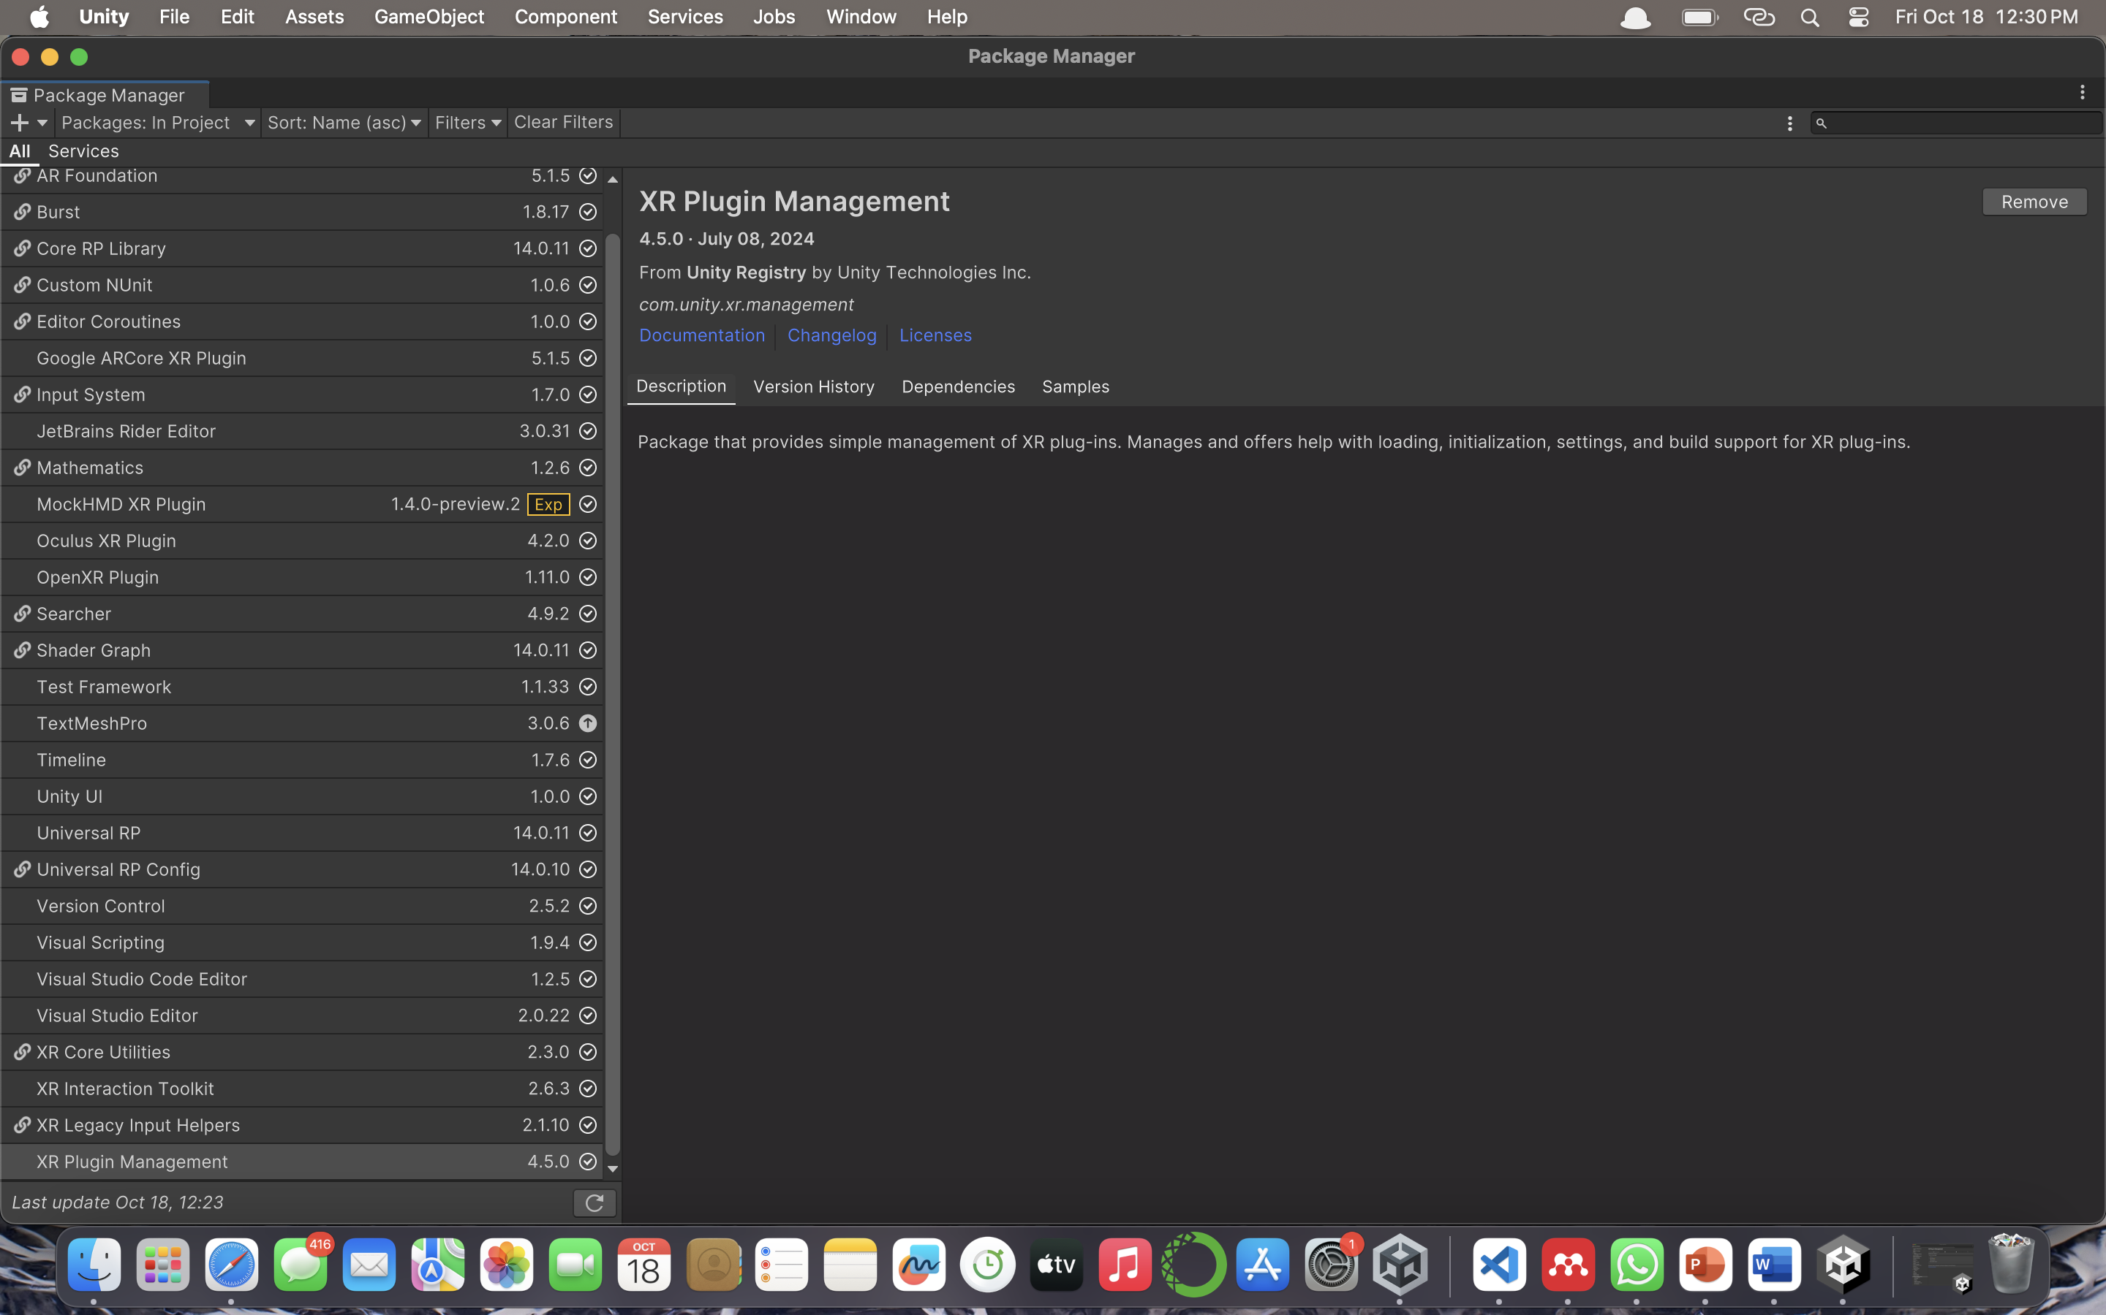

**TASK 2 : Create the ground plane and add skybox**

Steps:-

* Importing free asset of terrain from online unity’s asset store.
* Importing free asset of skybox from online unity’s asset store.
* With the help of terrain brush made the bulges on the terrains to look like mountains and used the hole painter of unity to create a hole for lava.

Screenshots:-

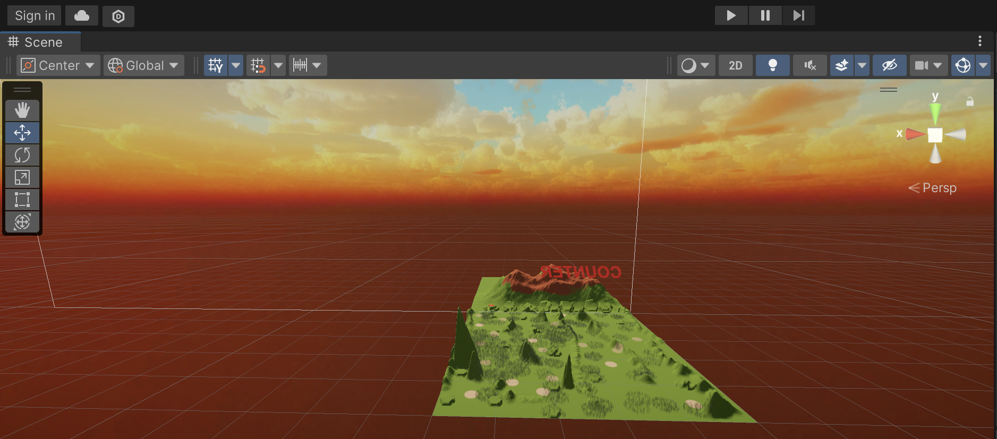

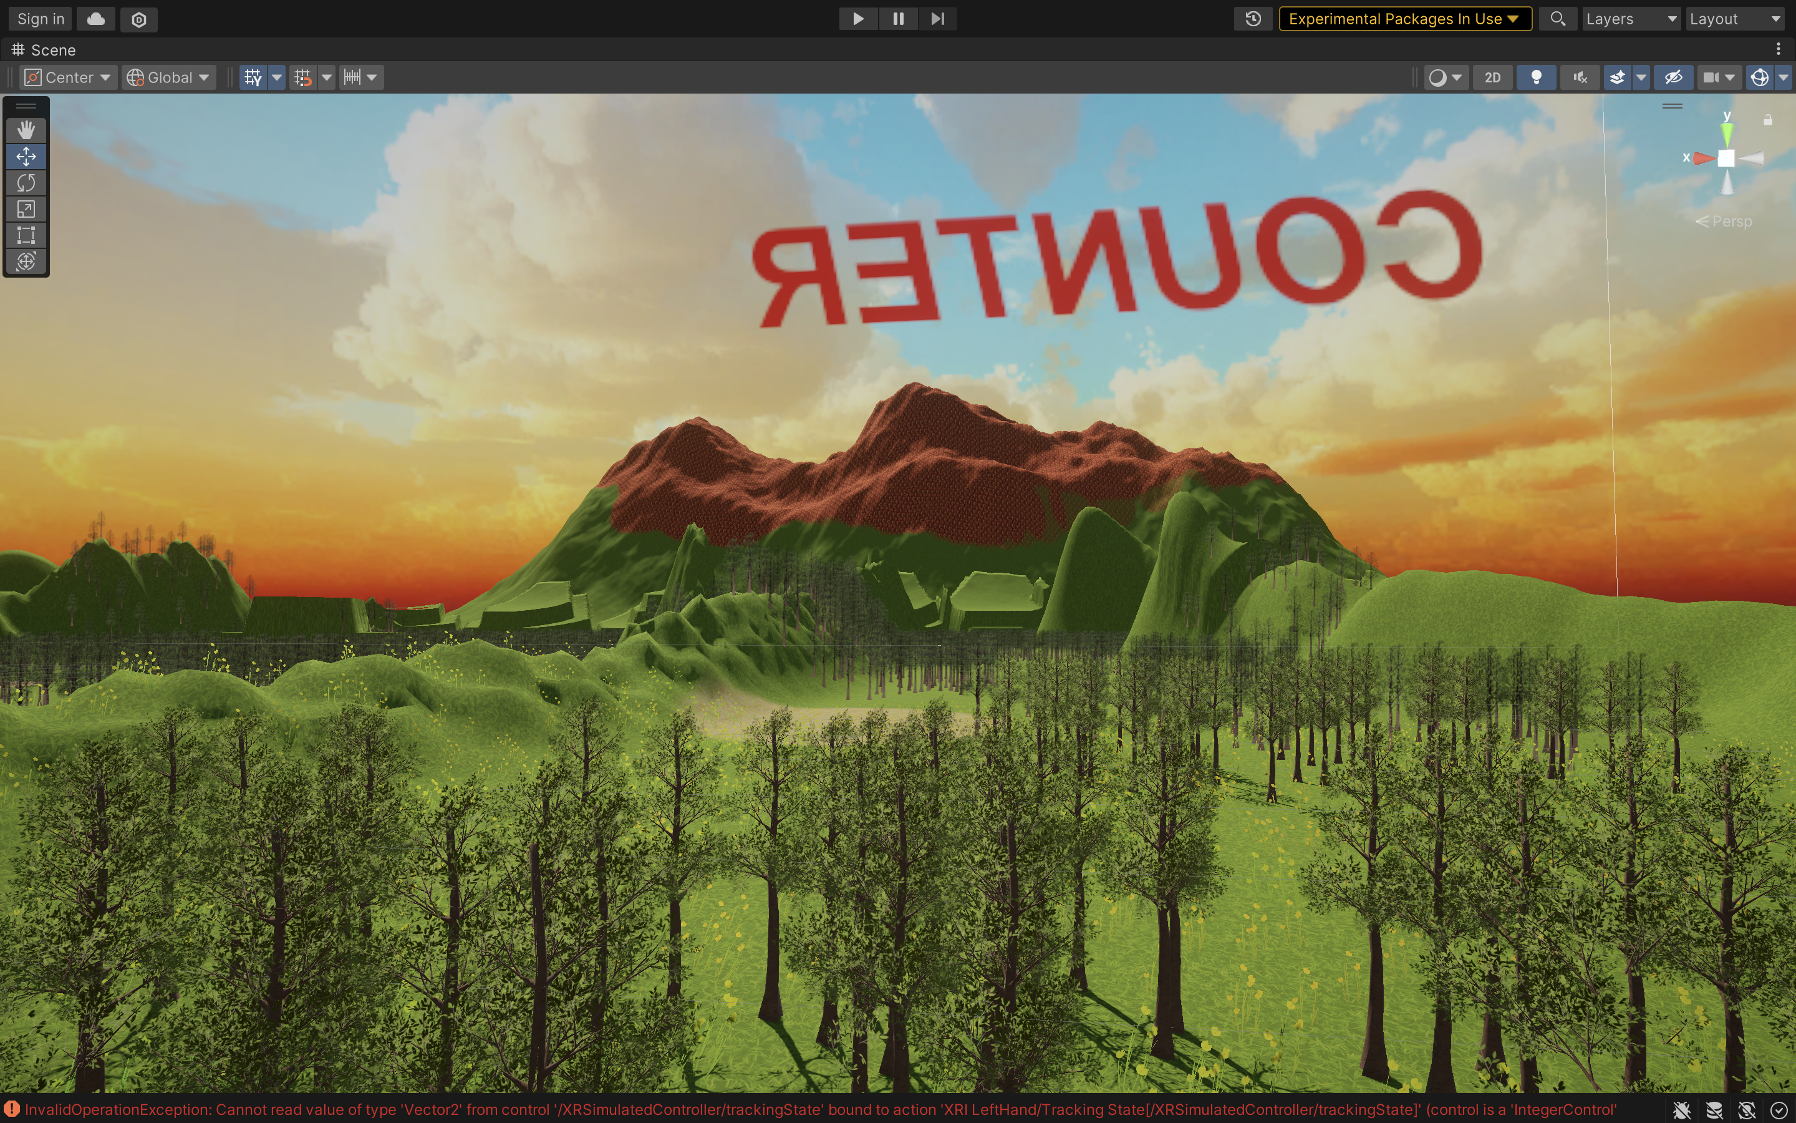

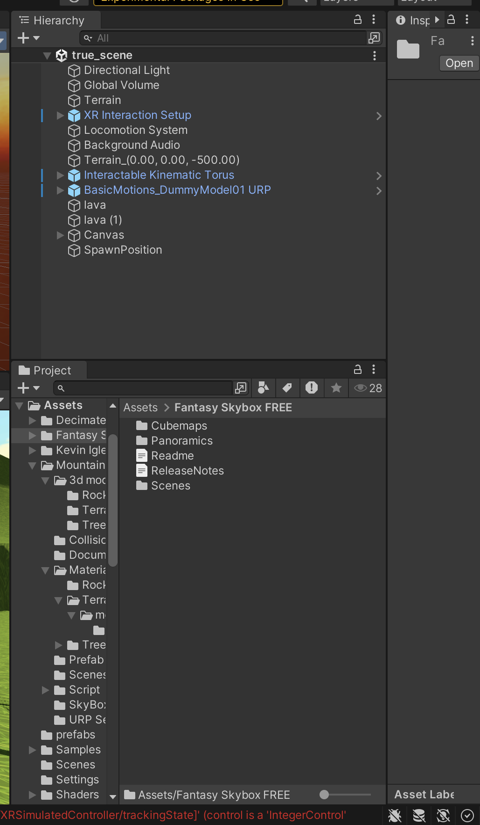

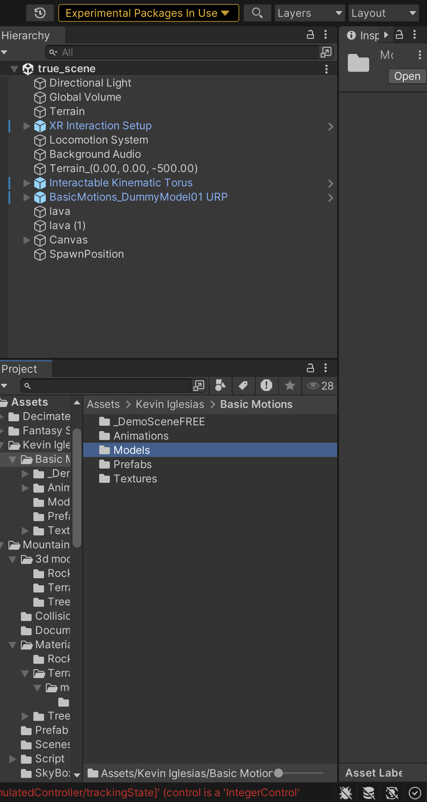

**TASK 3 : Add environment object**

Steps:-

* Expanded the size of terrain x:100 | y:1| z:100 so that there is enough place for the player to walkthrough.
* Imported free assets of trees, flowers and rocks to make terrain look more appealing.
* Added free assets of lava to increment in the game logic and added it’s flowing animation.

Screenshots:-

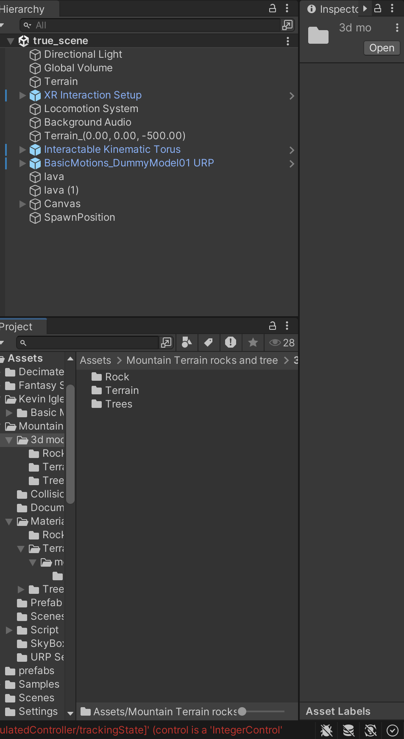

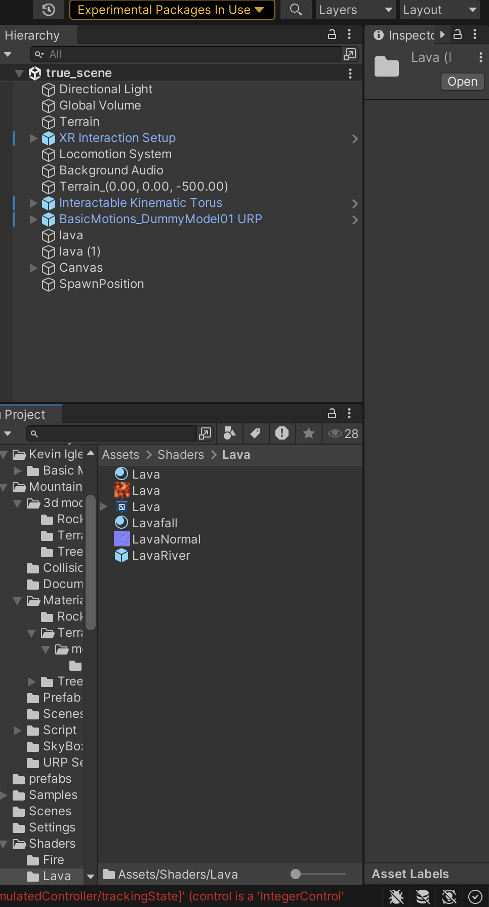

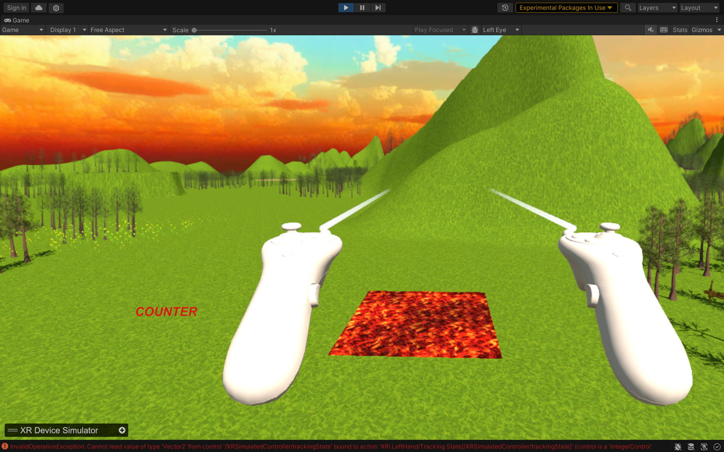

**TASK 4 : Configure lighting and shadow**

Steps:-

* Added directional light to simulate the sunlight
* Baked lightmaps
* Generated and configured real-time lightmaps

Screenshots:-

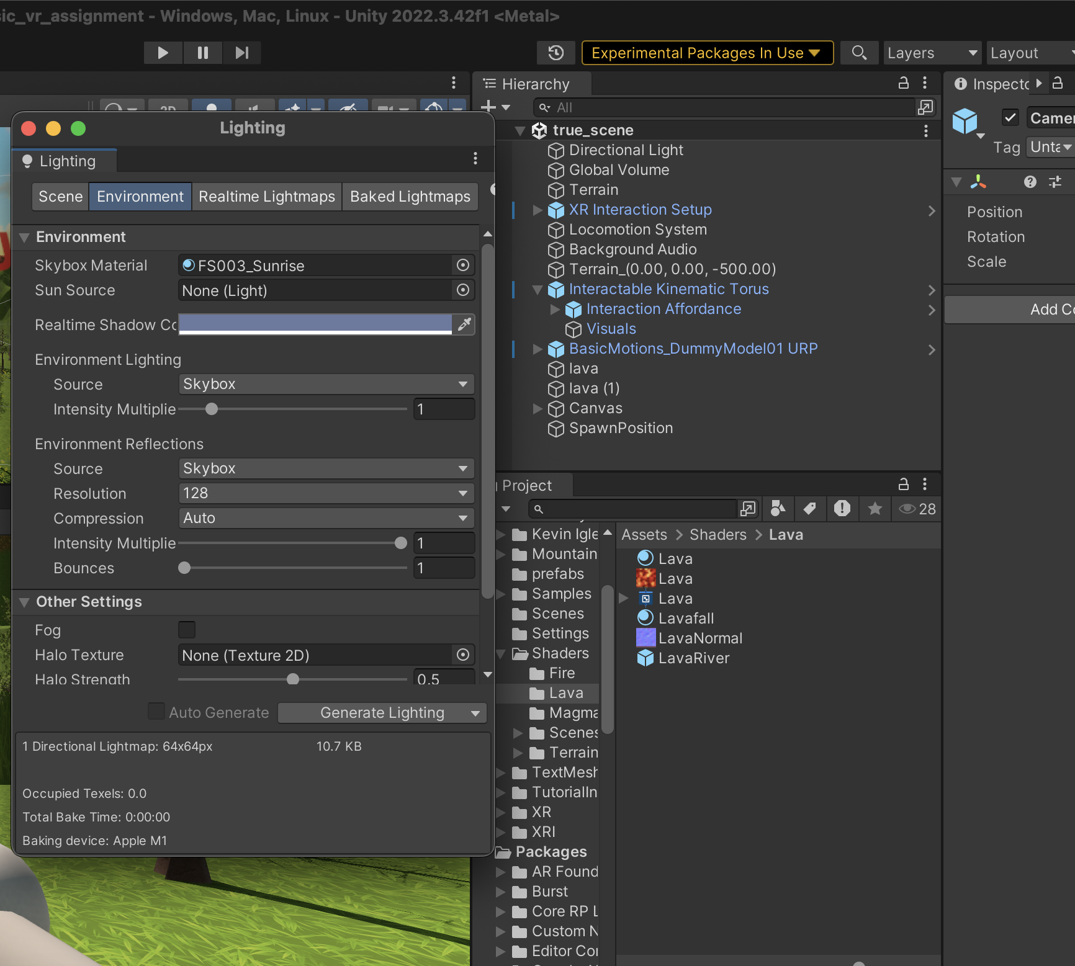

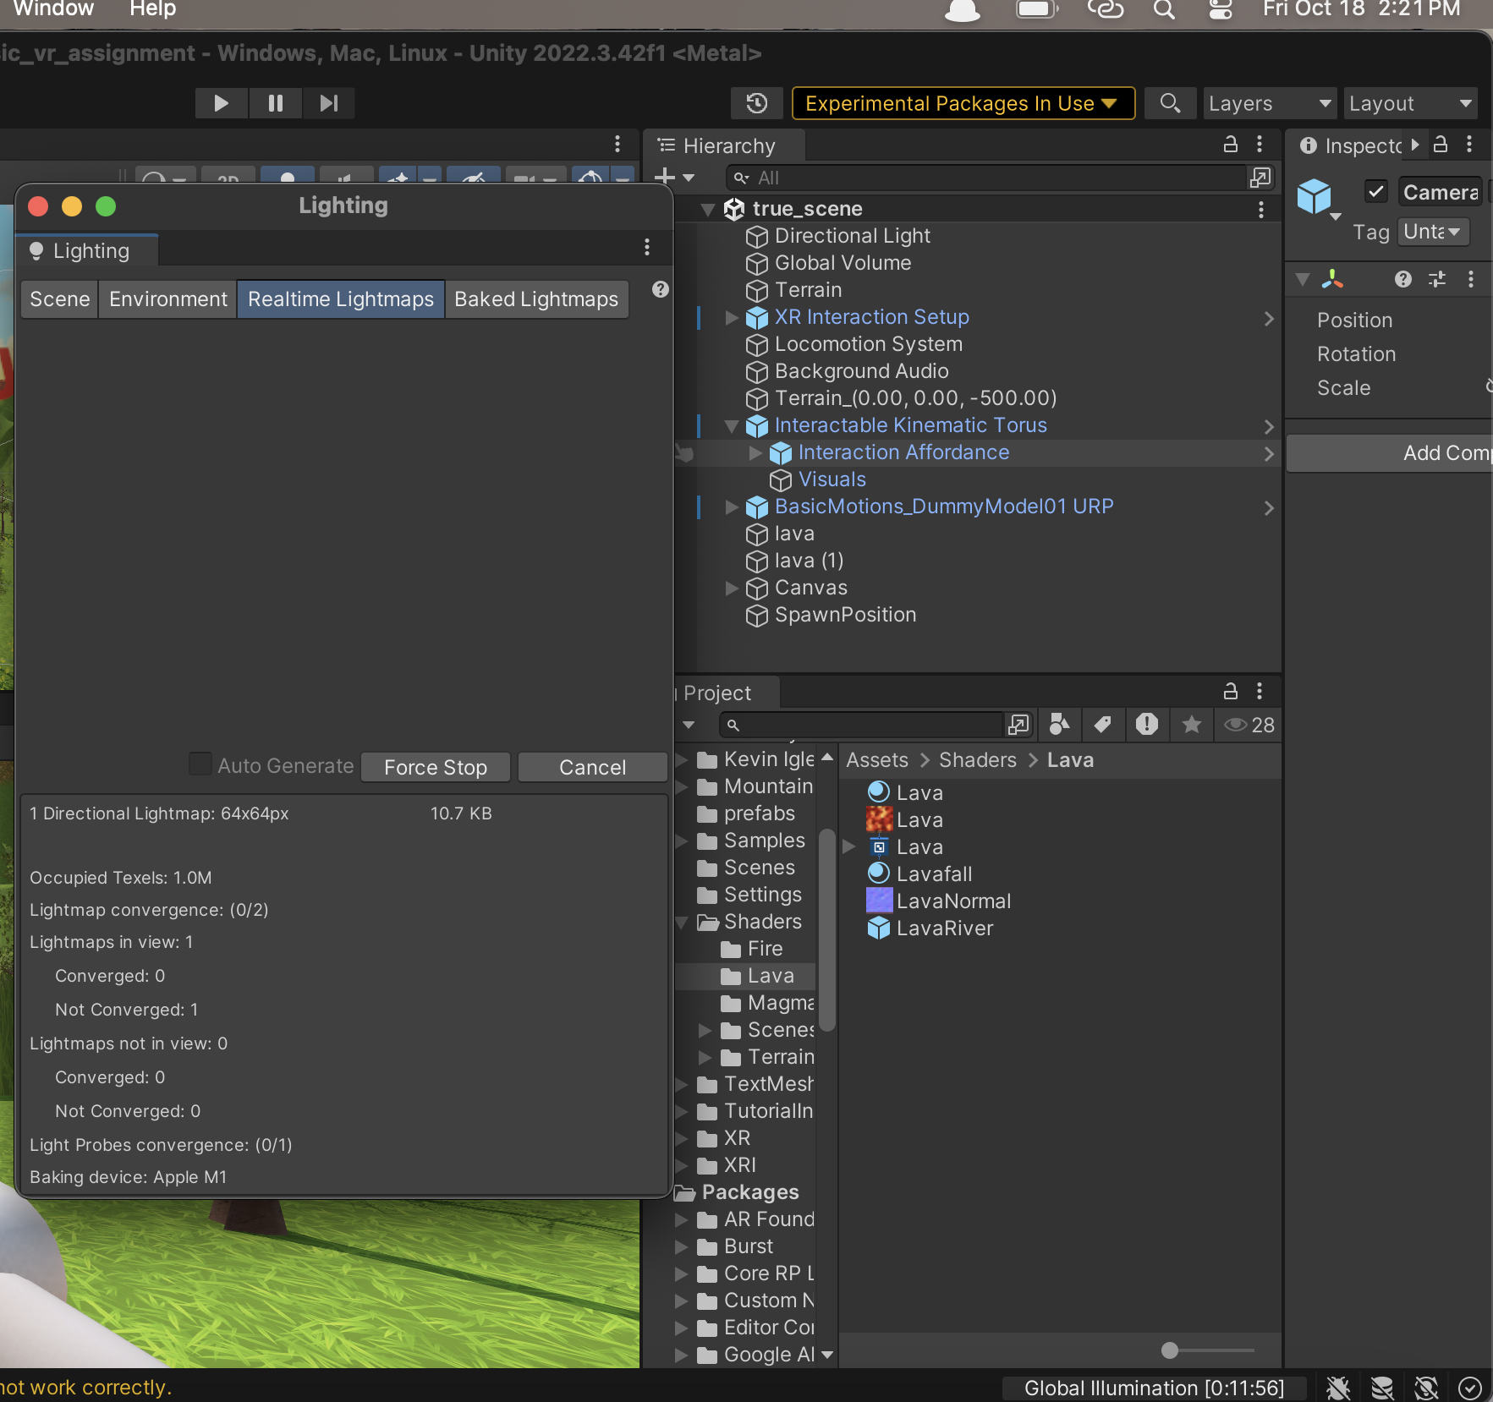

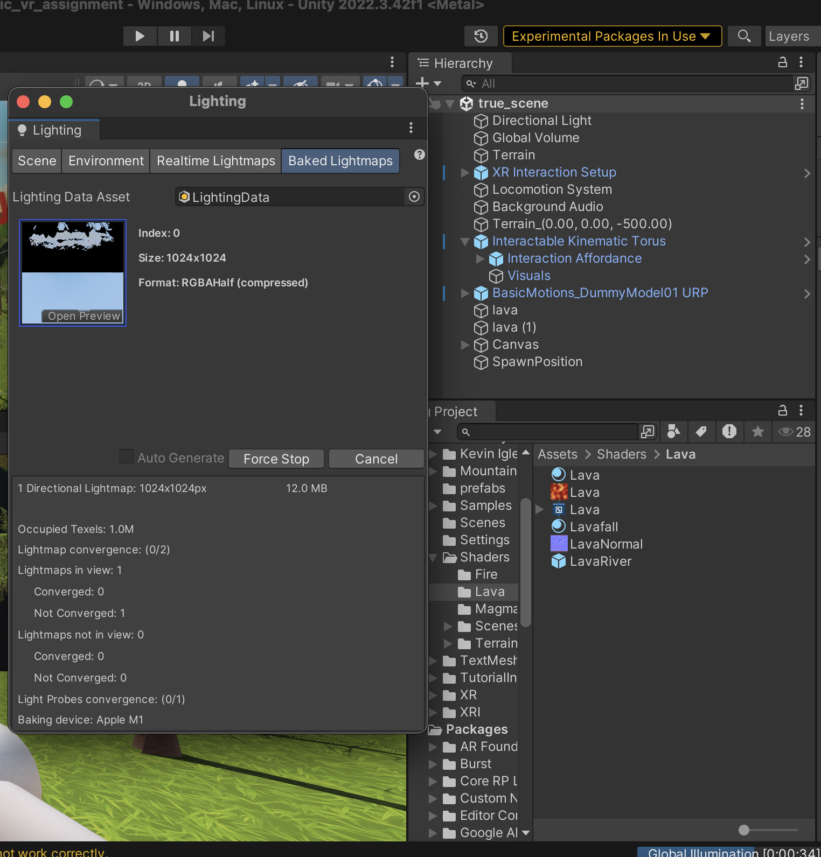

**TASK 5 : Add Audio**

Steps:-

* Got a NCS (non-copyright sound) from internet
* Created an empty game object name background-music
* Added audio component in that game object and then assigned the audio to the component

Screenshots:-

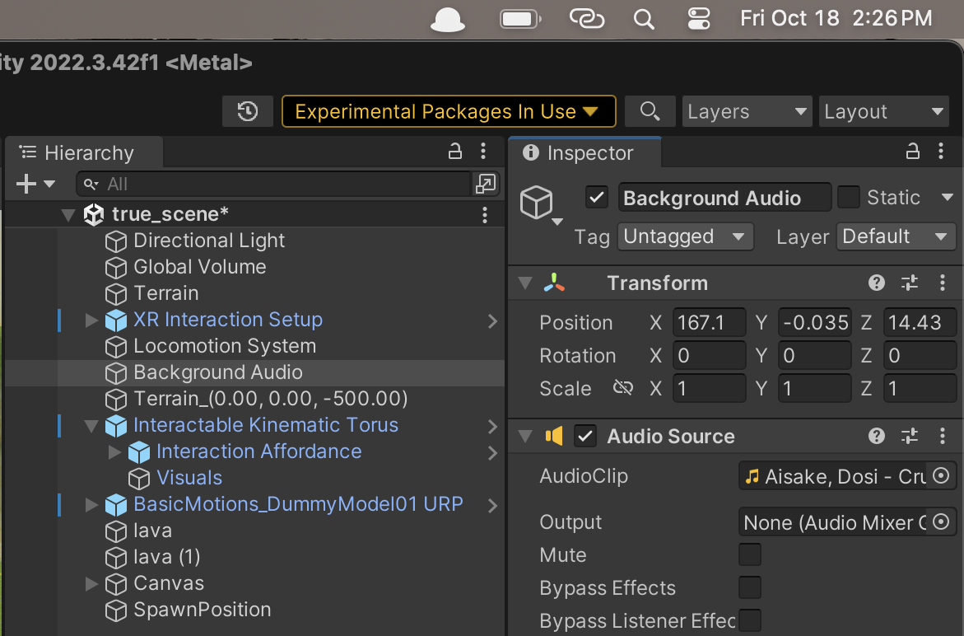

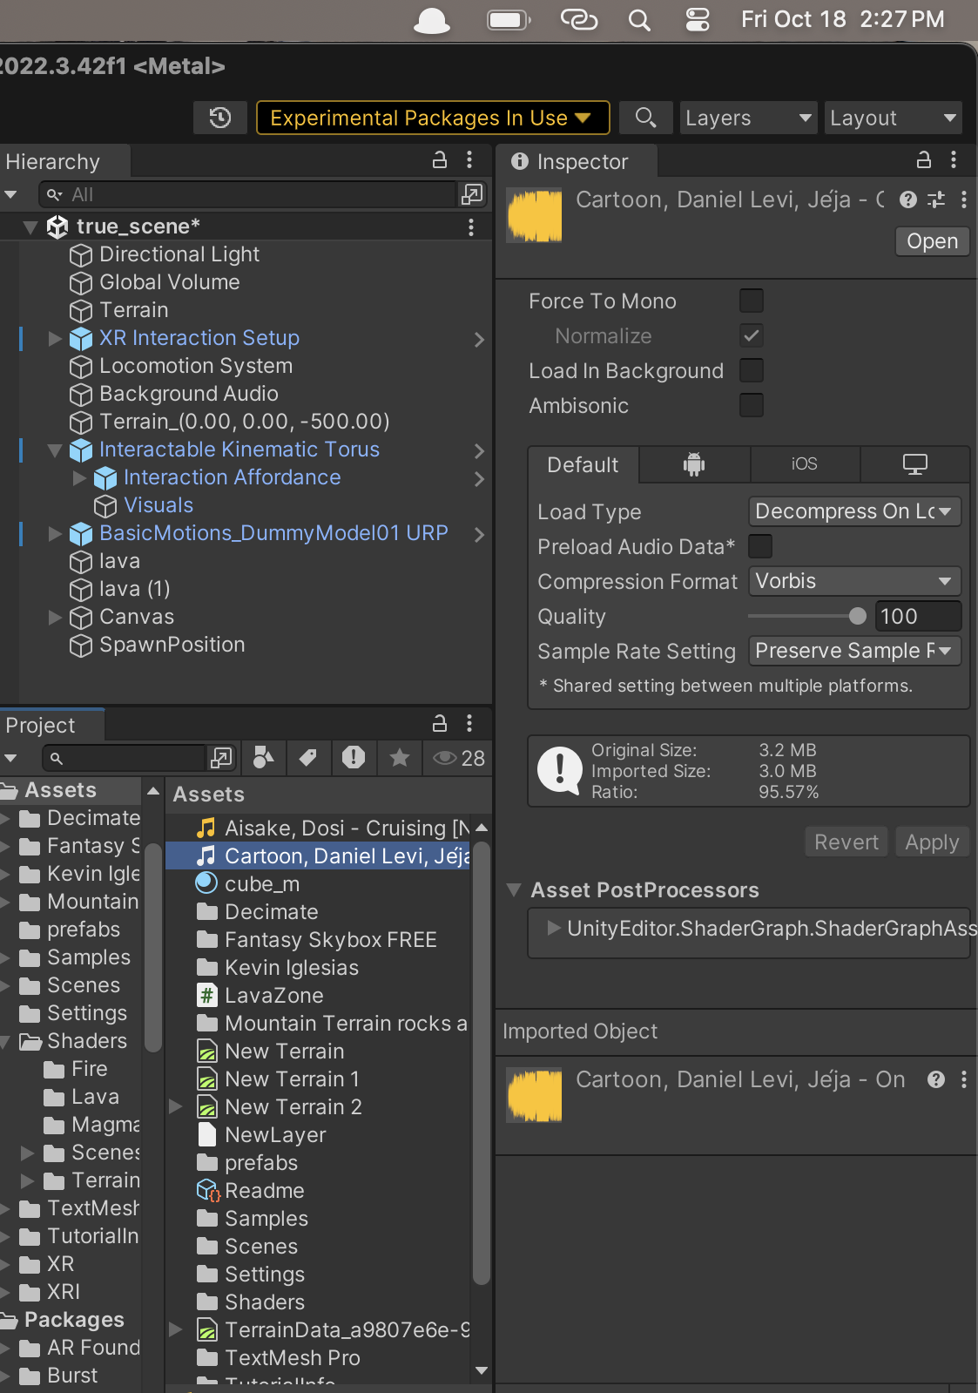

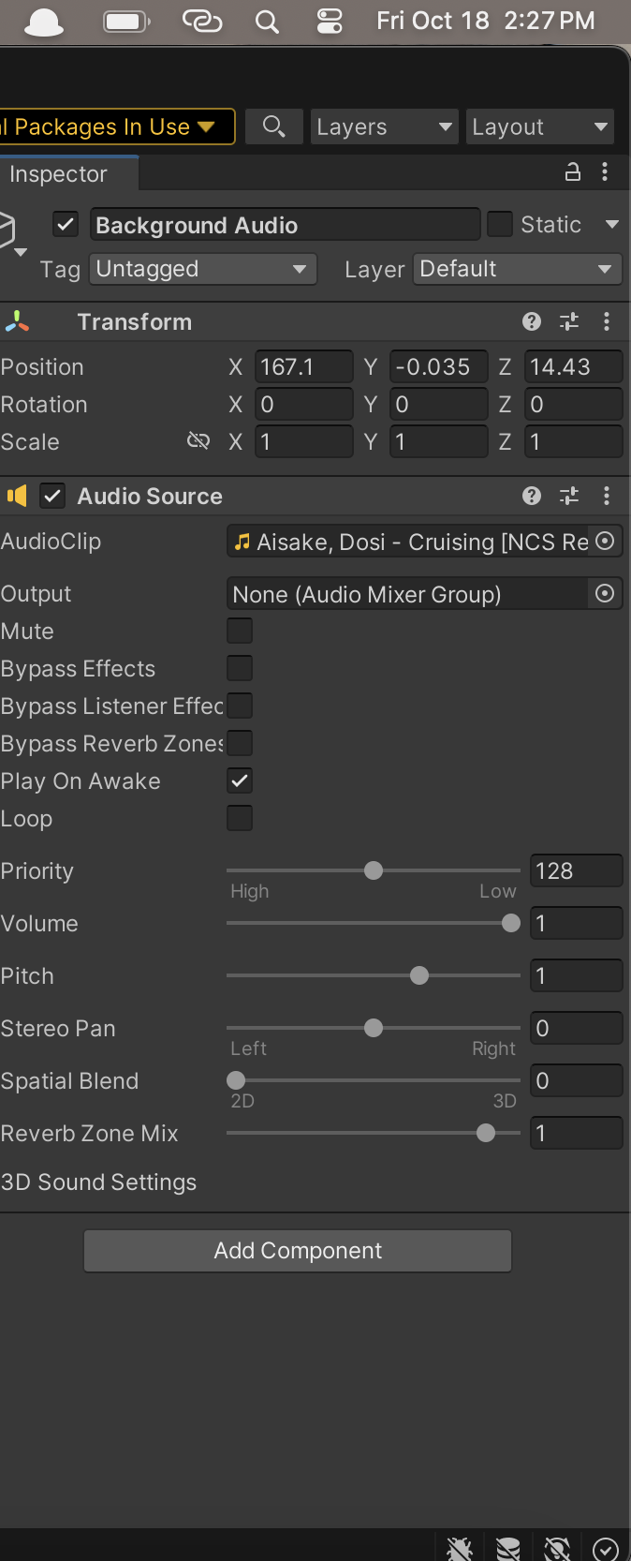

**TASK 6 : Implement basic vr interaction**

Steps:-

* Configure the grabbable object using xr toolkit’s xr grab interactable script.
* Add grabber components to the controllers.
* Importing asset of dummy for free from unity asset store.
* Adding xr grabinteractable component to it.
* Add in the animations on the dummy through animators.
* Configure vr simulator’s interaction.

Screenshots:-

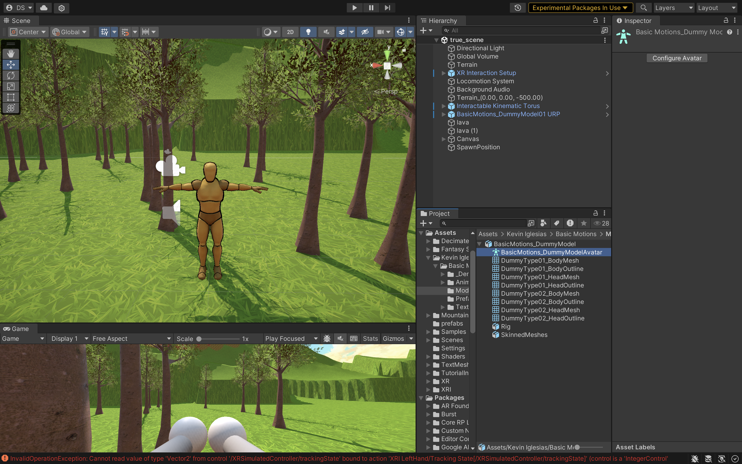

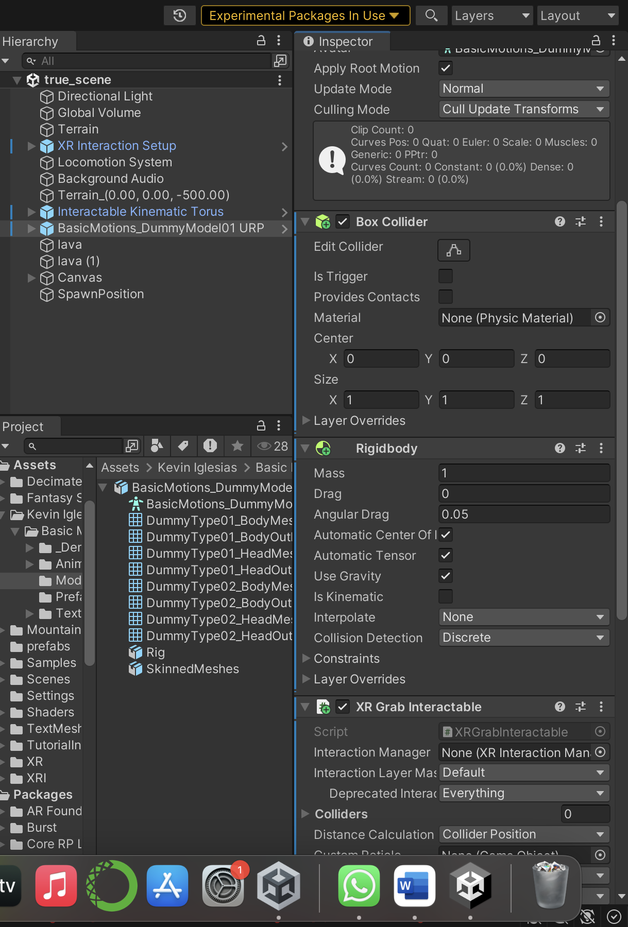

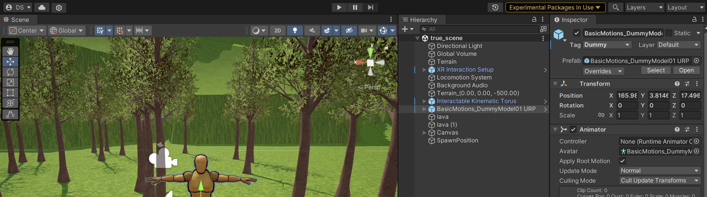

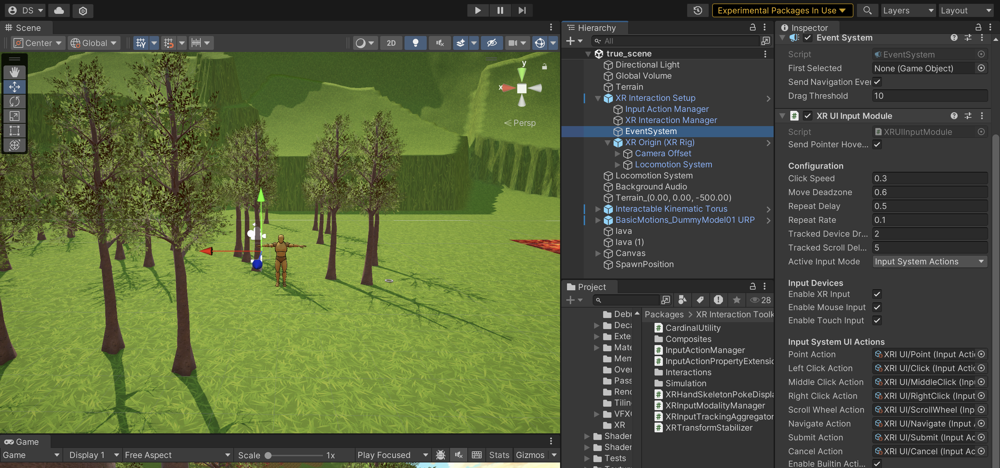

**TASK 7 : Write VR interaction script**

1. **Grab Interactable**

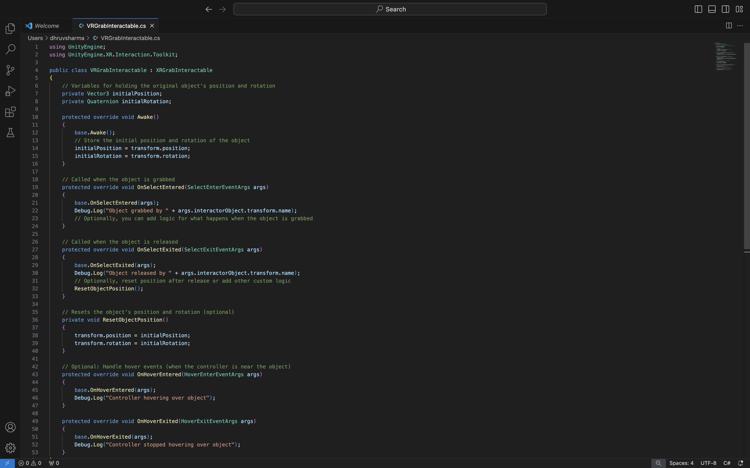

1. **Locomotion**

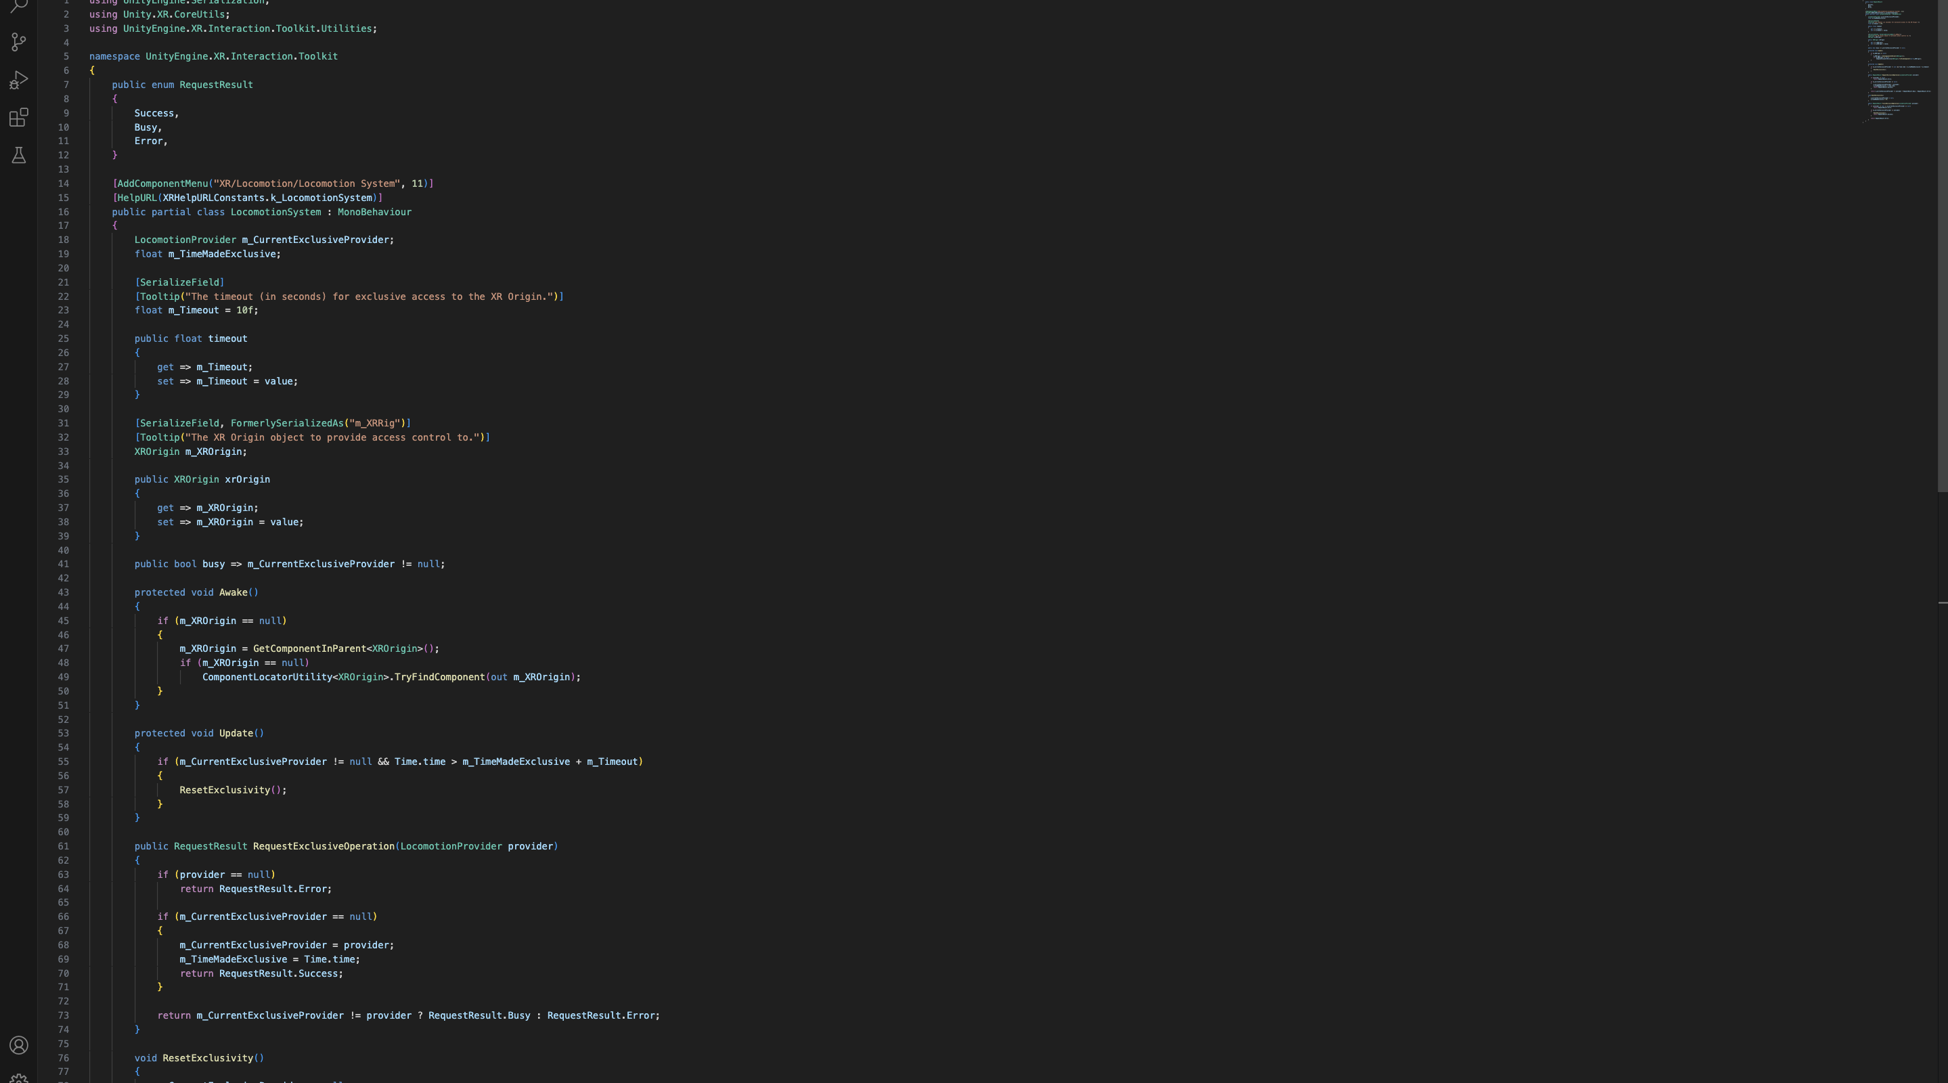

1. **Re-spawnner and counter [LAVAZONE]**

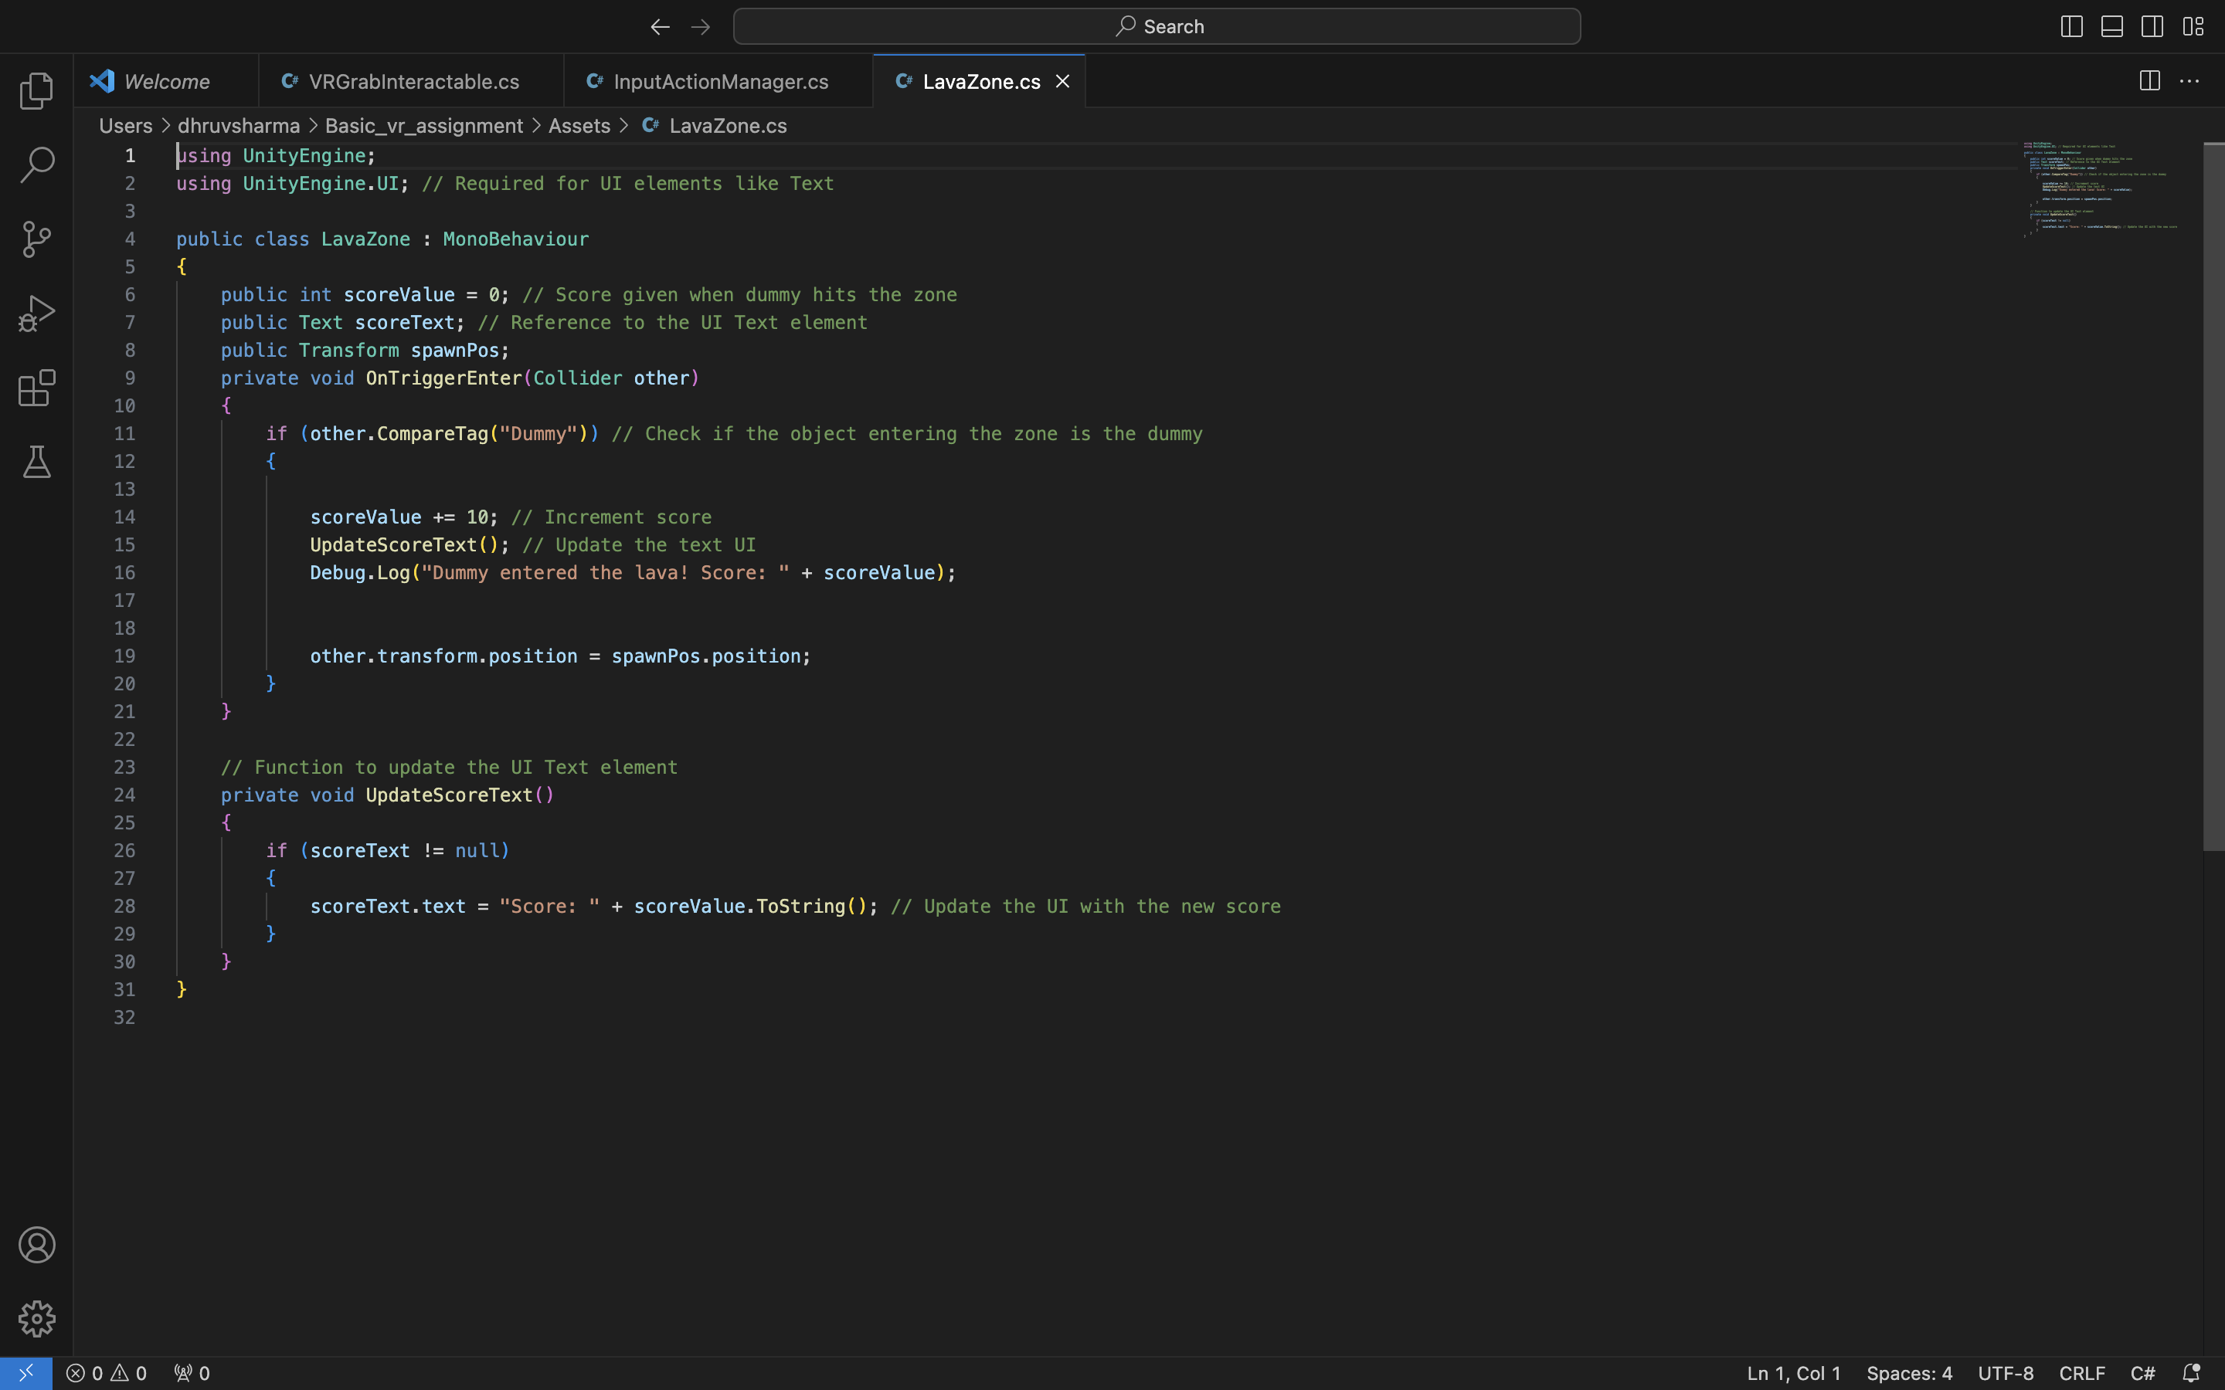

{This particular script consists of both respawn at the same location and increment on the counter when the dummy is disposed in the lava.}

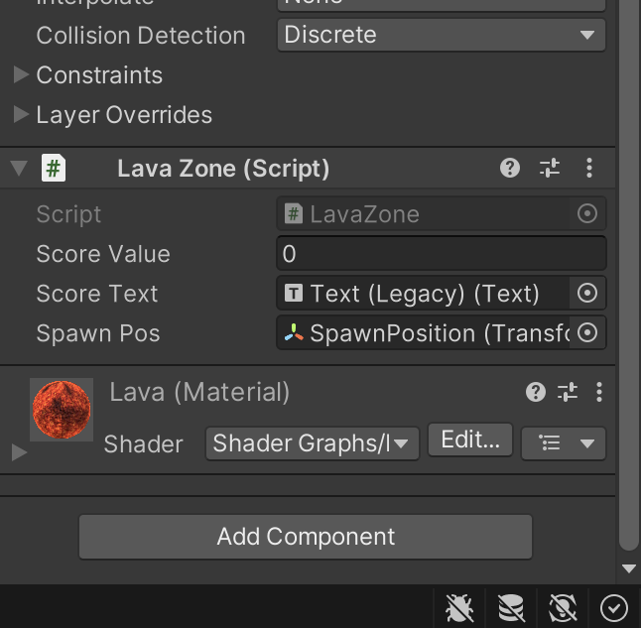

**TASK 8 : Create a scoring mechanism**

Created a scoring mechanism where when a player grabs the grabbable dummy and throws it through the lava pit the score increments by 10.

Steps :-

* Create a lava pit by erasing some terrain blocks and replacing them with a lava block.
* Keep the box to on trigger and keep the lava passable.
* Adding the script LavaZone as assign the prefabs to the variables created in the script for them.
* Detect the dummy passing through with help of OnTriggre event.
* Display the score to the player using legacy text and add this text to the variable position in the script LavaZone.

Screenshots:-

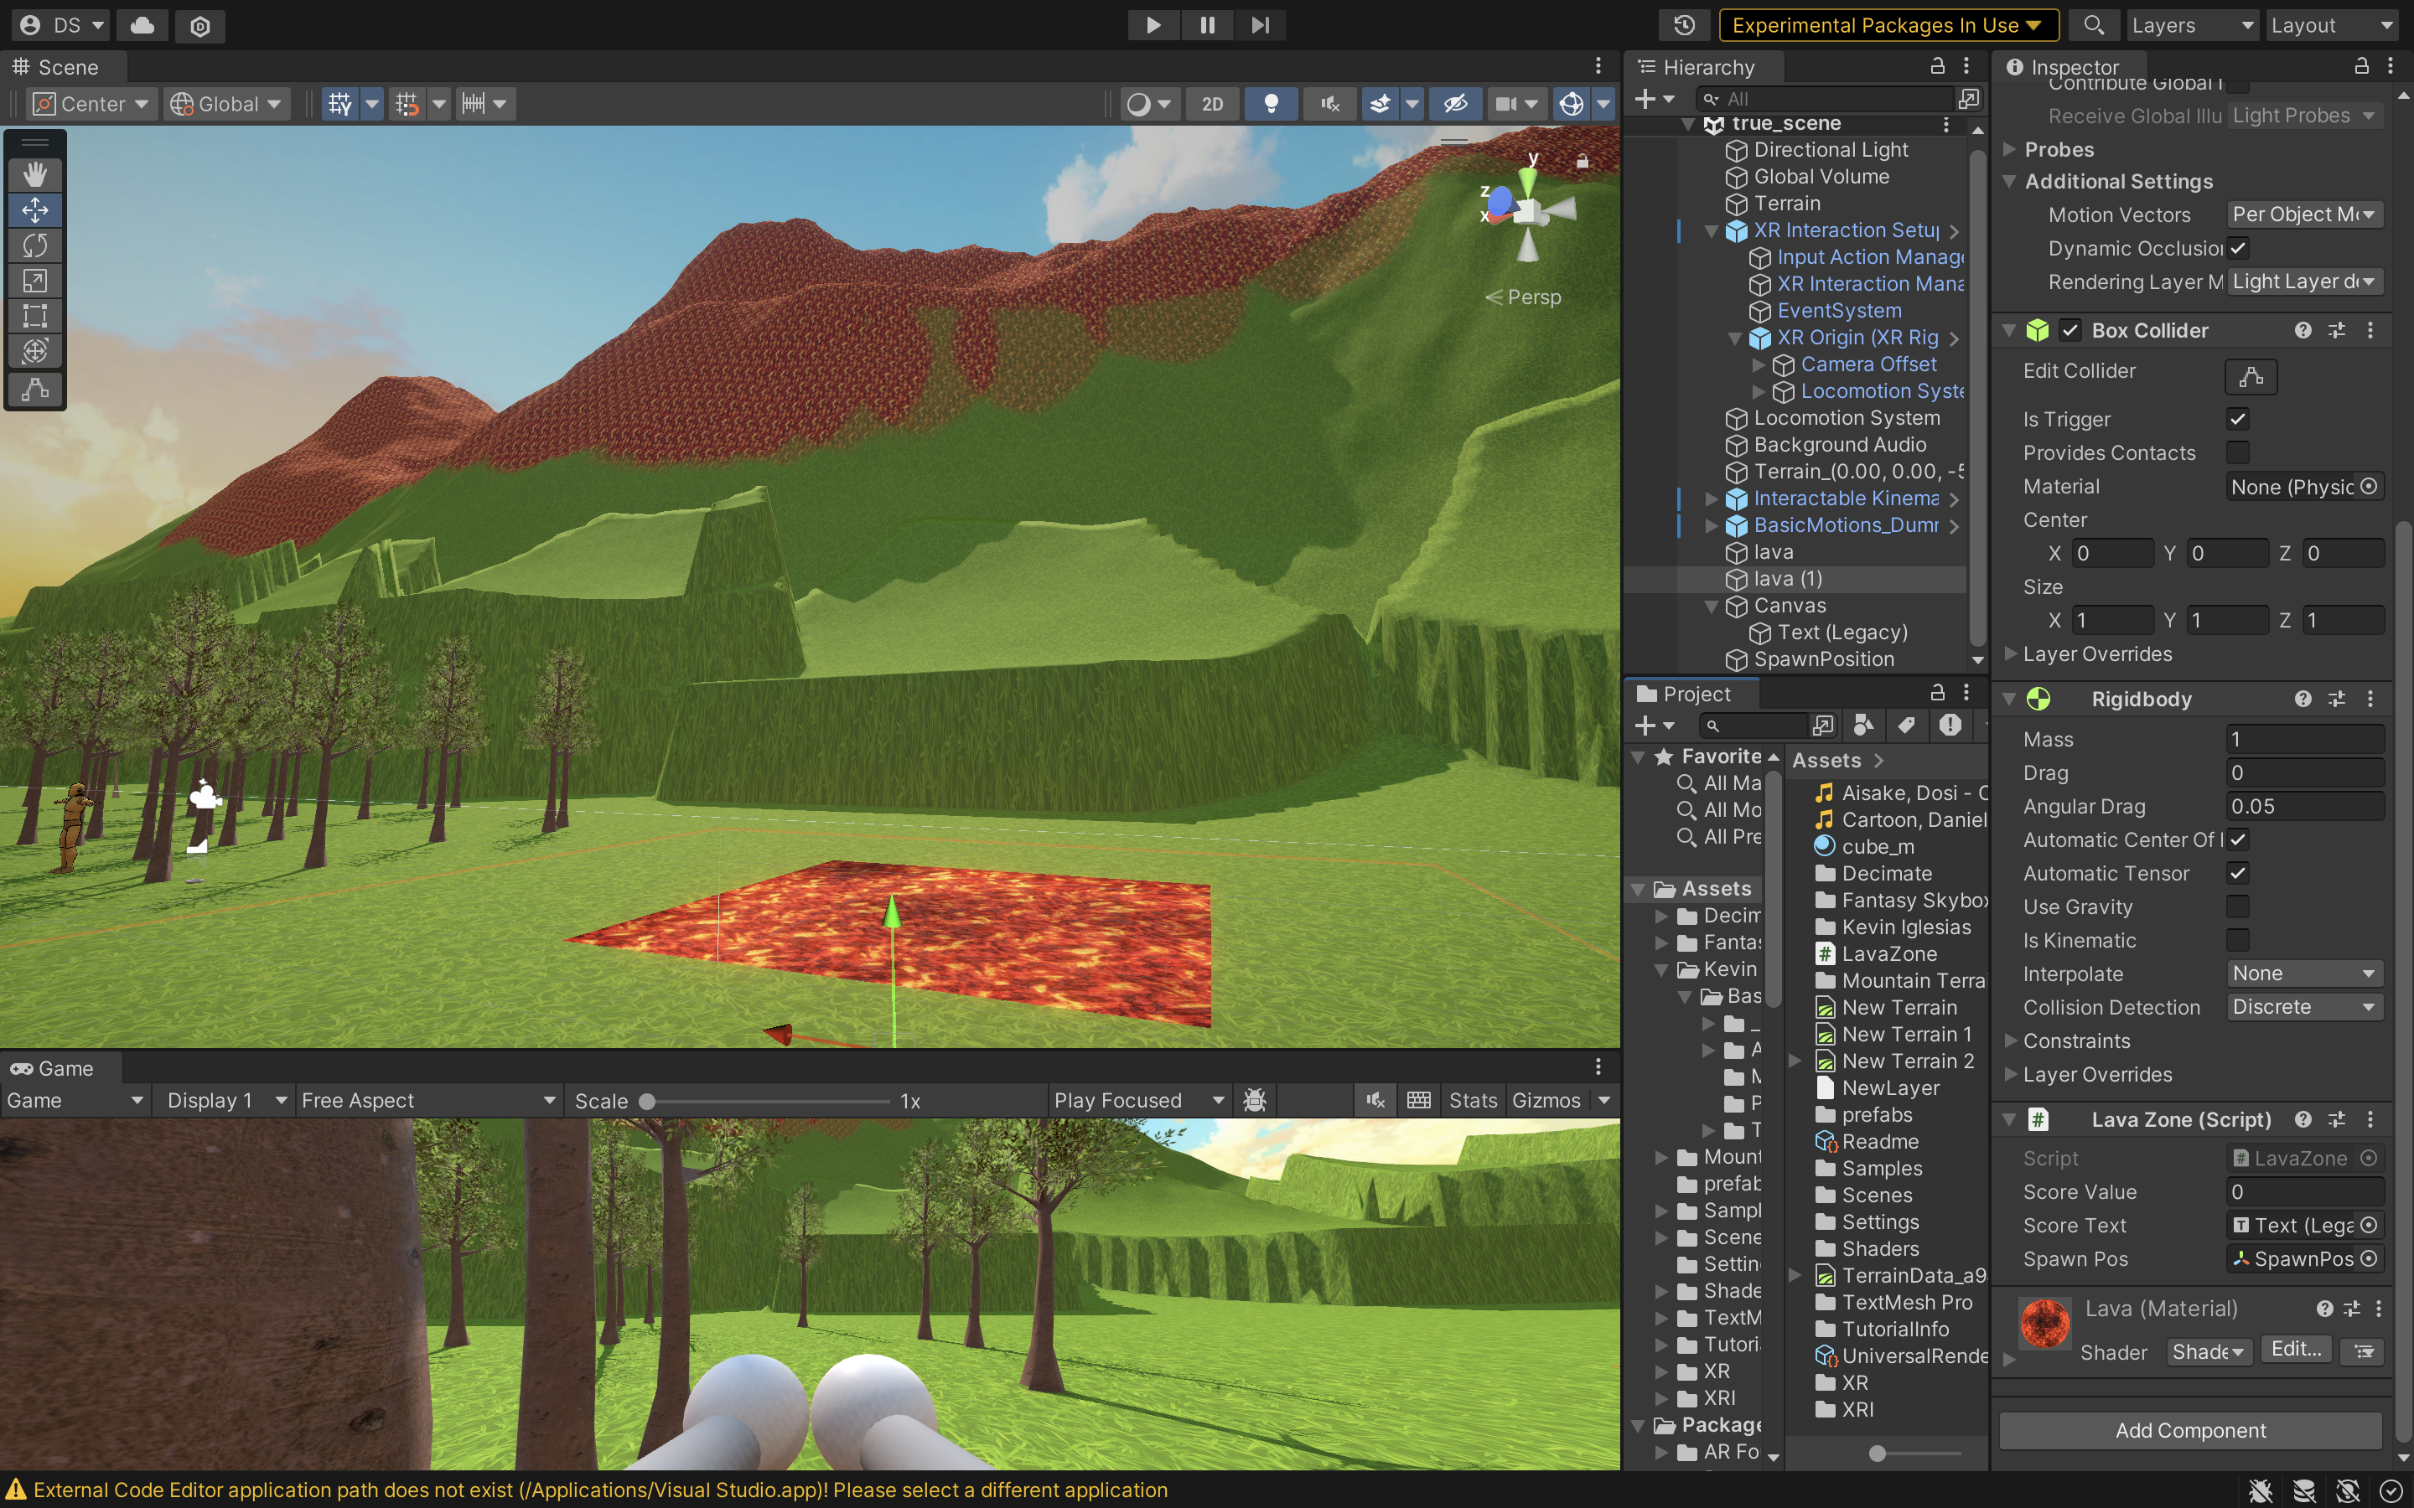



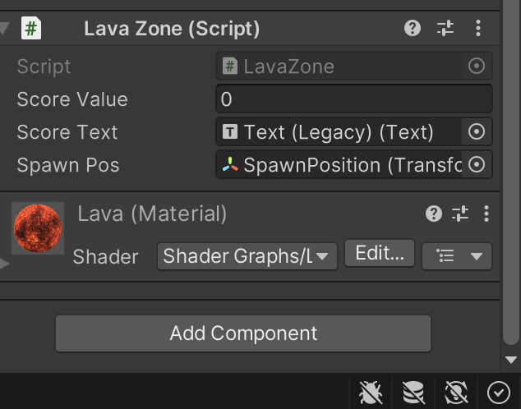

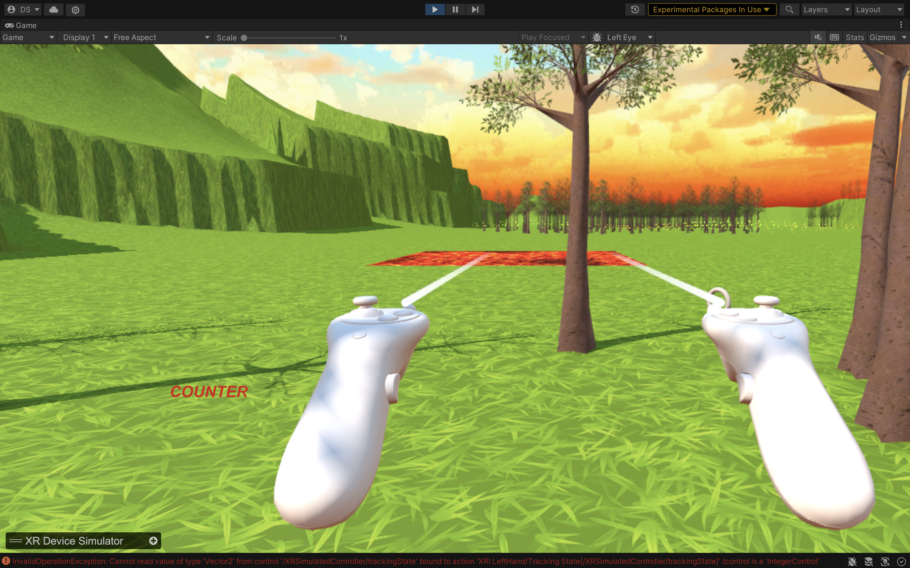

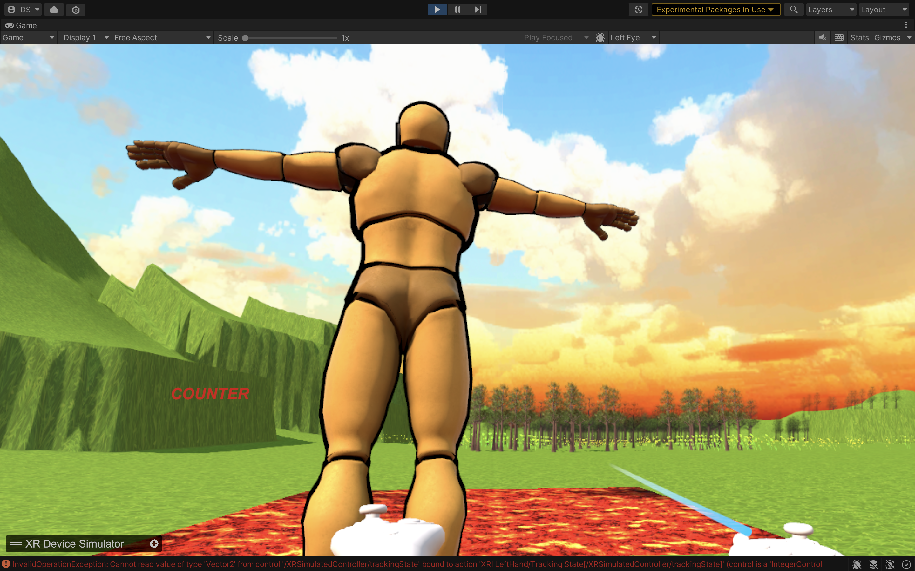

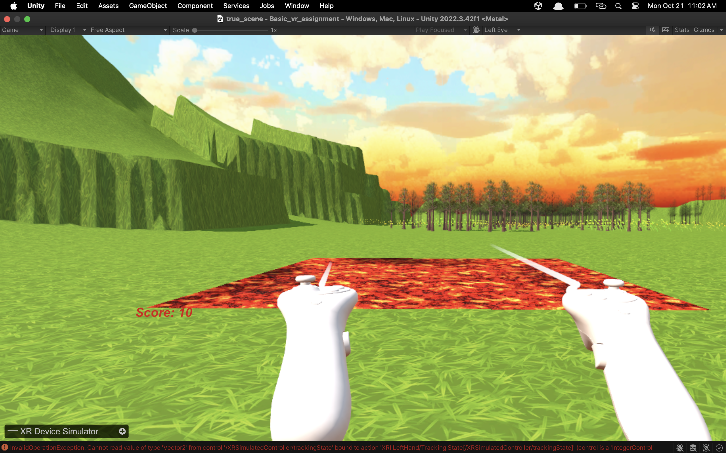

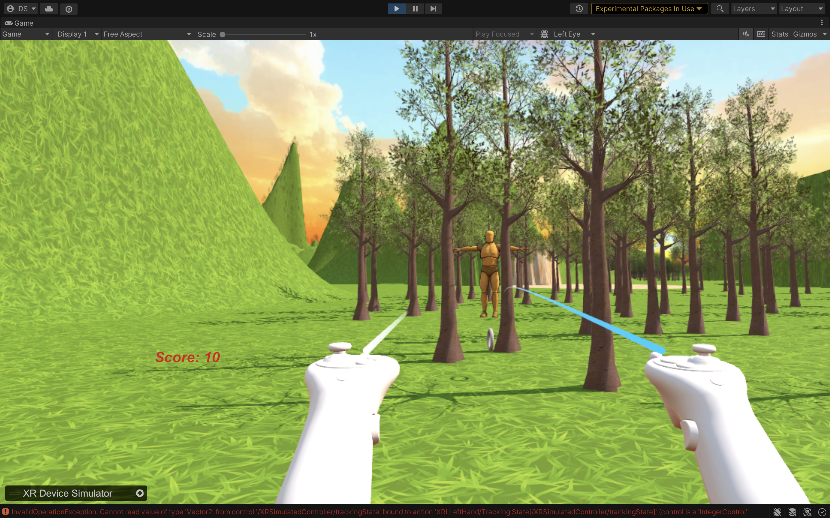

Github Repo Link: https://github.com/OPSdrag/LavaZone-VR